Class I E.St. – 23rd July 2019; Tuesday
1. Which among the following is not sweet to taste?
i. Lemon ii. Chocolate iii. Milk Shake iv. Cake
2. If, today is Sunday, which day is it tomorrow?
i. Saturday ii. Friday iii. Tuesday iv. Monday
3. Which among the following are ten in number?
i. Toes ii. Thumbs iii. Eyes iv. Head
4. Which among the following moves on the walls of our room?
i. Snake ii. Lizard iii. Cow iv. Goat

******************************************************************

Class II E.St. – 23rd July 2019; Tuesday
1. Which among the following is the young one of a cow?
i. pup ii. kitten iii. calf iv. cub
2. What is the colour of Orange juice?
i. Yellow ii. Orange iii. Red iv. Pink
3. Which flower-stick has thorns?
i. Sunflower ii. Jasmine iii. Marigold iv. Rose
4. How many days are there in a week?
i. Six ii. Eight iii. Seven iv. Ten

******************************************************************
Class III Science. – 23rd July 2019; Tuesday
1. Which among the following is not a part of nature?
i. Sun, Moon and Earth ii. Plants, Animals and Microbes
iii. Soil, Air and Water iv. Cars, Jeeps and Trucks
2. Which among the following is a plant product?
i. cotton ii. rubber iii. wool iv. leather
3. Which among the following brays?
i. horse ii. cow iii. donkey iv. monkey
4. Birds do not have_______________
i. feathers ii. arms iii. beaks iv. tail
******************************************************************
Class IV Science. – 23rd July 2019; Tuesday
1. Which among the following is a protein rich food?
i. bread and butter ii. pasta and noodles
iii. beans and lentils iv. soup and potato wafers
2. Which among the following is not a liquid?
i. water ii. milk iii. mercury iv. gold

3. Which among the following does not dissolve in water?
i. oil ii. sugar iii. salt iv. soap
4. Which among the following is not man-made?
i. plastic ii. glaciers iii. dams iv. bridges
******************************************************************
Class V Science. – 23rd July 2019; Tuesday
1. Which among the following is not a stringed musical instrument?
i. Tabla and Dhagga ii. guitar iii sitar iv. Violin
2. When is the World Environment Day observed every year?
i. 5th of July ii. 5th of June iii 5th of August iv. 5th of January
3. Which among the following is not a natural resource of water?
i. lakes and ponds ii. glaciers iii rivers iv. aquarium
4. What is the full form of the International Organisation WHO? ______________
*****************************************************************
Class VI Science. – 23rd July 2019; Tuesday
1. Tigers and Lions have two pairs of sharp tearing teeth called C______________ (7); these teeth are well developed in all C___________________ (10)

2. The bite of the female Aedes mosquito spreads the disease called D____________ (6); the mosquito does not suffer from the disease, it is a V_______________ (6)

3. Ostrich and Emu are birds that cannot f______ (3). They are found in the continent of A______________________ (9)

4. Dried g______________ (6) are known as raisins/ kishmish;if soaked in water they swell by a process known as O_______________ (7)
*****************************************************************

Class VII Science. – 23rd July 2019; Tuesday
1. Which among the following statements IS an INCORRECT statement?
i. Green plants have chlorophyll. ( ) ii. Blood cells have haemoglobin. ( )
iii. Mammals lay eggs ( ) iv. Birds have air filled bones ( )

2. Which among the following is A MODIFIED STEM?
i 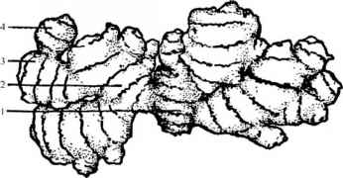 ( ) ii 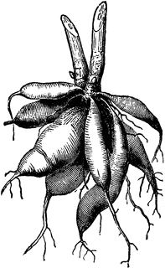 ( )
iii. 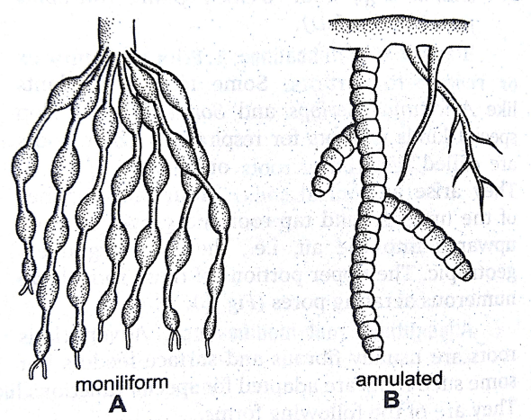 ( ) iv. ( )

3. Which among the following pairs are INCORRECT?
i. C- Carbon. ( ) ii. Co- Cobalt ( ) iii.Al- Aluminium ( ) iv. Hg- Hydrogen ( )

4. Which among the following IS NOT a SPICE?
i. Cardamom ( ) ii. Clove ( ) iii Asafoetida ( ) iv. Arrowroot ( )

********************************************************************************************

Class VIII Science. – 23rd July 2019; Tuesday
1. Which among the following STATEMENTS IS FALSE?
i. In countries across the globe cereals are the staple food and diet. ( )
ii. Vegetables and fruits are sources of vitamins and minerals ( )
iii. Water is not essential for digestion and assimilation of food. ( )
iv. Pulses, milk, eggs, meat and fish are rich sources of proteins ( )

2. “Operation Flood” deals with which one of the following?
i. Safeguarding villages and cities from flood ( )
ii. construction of dams to prevent flood ( )
iii. production of fishes and fish products. ( )
iv. India’s largest dairy development programme ( )

3. Expand the abbreviation of ISRO
__________________________________________________________________

4. Which among the following is not a metal?
i. mercury- Hg ( ) ii. manganese – Mn ( ) iii. Hydrogen- H ( ) iv. Magnesium- Mg ( )
*******************************************************************************************
Class IX Science. – 23rd July 2019; Tuesday
1. Who among the following scientists has received the Nobel Prize for ‘The Theory of Relativity?’
a. Albert Einstein [ ] b. C V Raman [ ] c. S Chandrashekhar [ ] d. H G Khorana [ ]

2. Which among the following is not a form of Carbon?
a. Graphite [ ] b. Sea-shell [ ] c. Soot [ ] d. Diamond [ ]

3 . Which among the following are incorrect?

a. Aryabhatta – Place Value System & Zero [ ] b. Jayant Narlikar – Physicist [ ]
c. Marie Curie- Filarial parasite life cycle [ ] d. Shakuntala Devi- Wizard in Calculations [ ]

4. If a car is moving at a Uniform Speed of 80 Kms per hour; what is the distance covered by it in 7.5 hours?
a. 600 km [ ] b. 560 km c. 660 km [ ] d. 800 km
.
*******************************************************************************************

Class X Science. – 23rd July 2019; Tuesday
3. Structural and functional unit of living organisms is the _________
4. Omnis cellula e cellula also refers to the ______________________
5. The motion of an object in a straight line is termed as ______________________
6. If a body covers equal distances in equal intervals of time then it is said to be having _________________.
*******************************************************************************************
Class XI Science. – 23rd July 2019; Tuesday
3. Who among the following Indian scientists has not been recognized with the Nobel Prize?
a. J C Bose [ ] b. C V Raman [ ] c. S Chandrashekhar [ ] d. H GKhorana [ ]
4. Which among the following are incorrect?
a. Limestone = Calcium Carbonate [ ] b. Baking Soda – Sodium Bicarbonate
c. Table Salt = Sodium Chloride [ ] d. Bleaching Powder – Rock Salt

5. Which among the following are incorrect?
a. Aryabhatta – Place Value System & Zero [ ] b. Birbal Sahani – Palaeobotany
c. APJ Abdul Kalam = Astronomy [ ] d. Shakuntala Devi- Wizard in Calculations
6. Which among the following is a non -communicable disease?
a. Malaria [ ] b. Common Cold [ ] c. Anaemia [ ] d. Influenza [ ]
*******************************************************************************************
Class XII Science. – 23rd July 2019; Tuesday
1. Who among the following scientists has received the Nobel Prize for ‘The Theory of Relativity?’
a. Albert Einstein [ ] b. C V Raman [ ] c. S Chandrashekhar [ ] d. H GKhorana [ ]

2. Which among the following pairs is incorrect?
a. study of birds- ornithology [ ] b. study of early stages of development - embryology [ ]
c. study of insects- entomology [ ] d. study of infants and children - palaeontology [ ]

3 . Which among the following are incorrect?

a. Aryabhatta – Place Value System & Zero [ ] b. Birbal Sahani – Zoologist
c. APJ Abdul Kalam - Missile Technology [ ] d. Shakuntala Devi- Wizard in Calculations [ ]

4 If a car is moving at a Uniform Speed of 60 Kms. per hour; what is the distance covered by it in 8.5 hours?
a. 600 kms. [ ] b. 510 kms. c. 480 kms. [ ] d. 610 kms.

*******************************************************************************************

